**ESTIMATED TIME : 15 mins**

**Create a single database**

A single database has a defined set of compute, memory, IO, and storage resources using one of two [purchasing models](https://docs.microsoft.com/en-us/azure/sql-database/sql-database-purchase-models). When you create a single database, you also define a [SQL Database server](https://docs.microsoft.com/en-us/azure/sql-database/sql-database-servers) to manage it and place it within [Azure resource group](https://docs.microsoft.com/en-us/azure/azure-resource-manager/resource-group-overview) in a specified region.

To create a single database containing the AdventureWorksLT sample data:

1. Select **Create a resource** in the upper left-hand corner of the Azure portal.
2. Select **Databases** and then select **SQL Database** to open the **Create SQL Database** page.

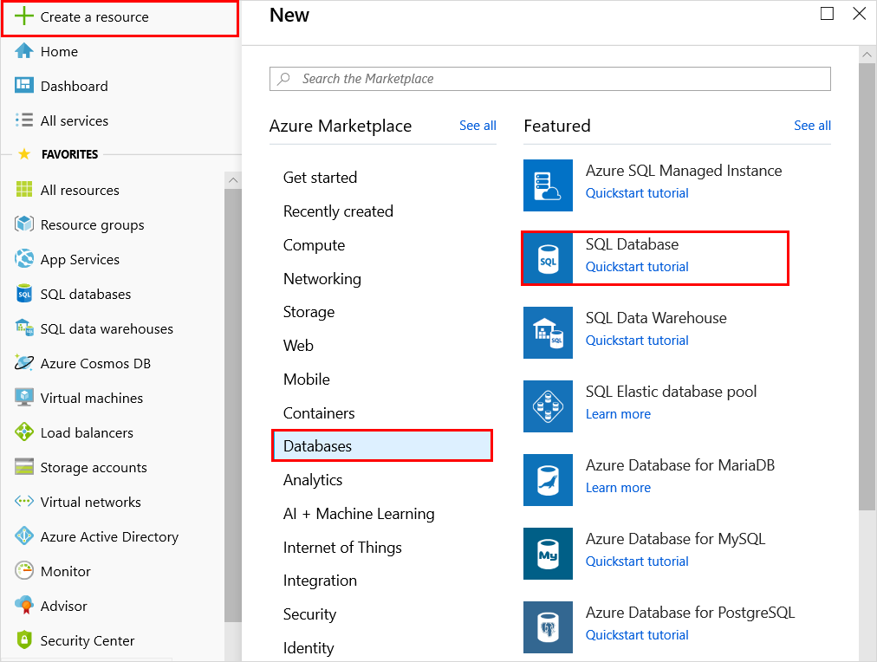

1. On the **Basics** tab, in the **Project Details** section, type or select the following values:
   * **Subscription**: Drop down and select the correct subscription, if it doesn't appear.
   * **Resource group**: Select **Create new**, type myResourceGroup, and select **OK**.

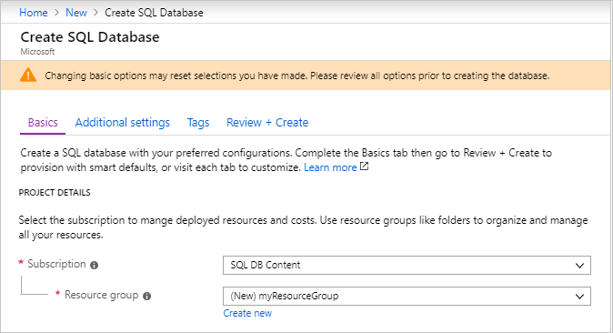

1. In the **Database Details** section, type or select the following values:
   * **Database name**: Enter mySampleDatabase.
   * **Server**: Select **Create new** and enter the following values and then select **Select**.
     + **Server name**: Type mysqlserver; along with some numbers for uniqueness.
     + **Server admin login**: Type azureuser.
     + **Password**: Type a complex password that meets password requirements.
     + **Location**: Choose a location from the drop-down, such as West US 2.

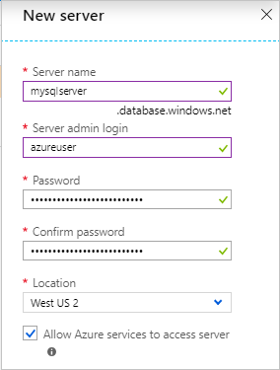

**Important**

Remember to record the server admin login and password so you can log in to the server and databases for this and other quickstarts. If you forget your login or password, you can get the login name or reset the password on the **SQL server** page. To open the **SQL server** page, select the server name on the database **Overview** page after database creation.

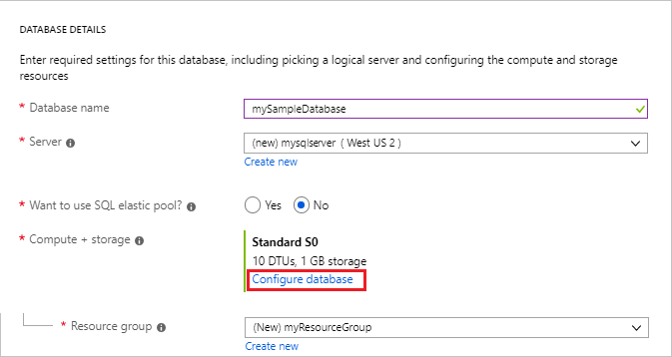

* + **Want to use SQL elastic pool**: Select the **No** option.
  + **Compute + storage**: Select **Configure database** and for this quickstart, select the **Basic** service tier, and then use the slider to select  **500MB** of storage. Select **Apply**.
  + **Check the amount it should be approx. 324/**- a month.

Leave the rest of the values as default and select **Review + Create** at the bottom of the form.

1. Review the final settings and select **Create**.
2. On the **SQL Database** form, select **Create** to deploy and provision the resource group, server, and database.